1. Artificial Neural Network (Accuracy 60%)

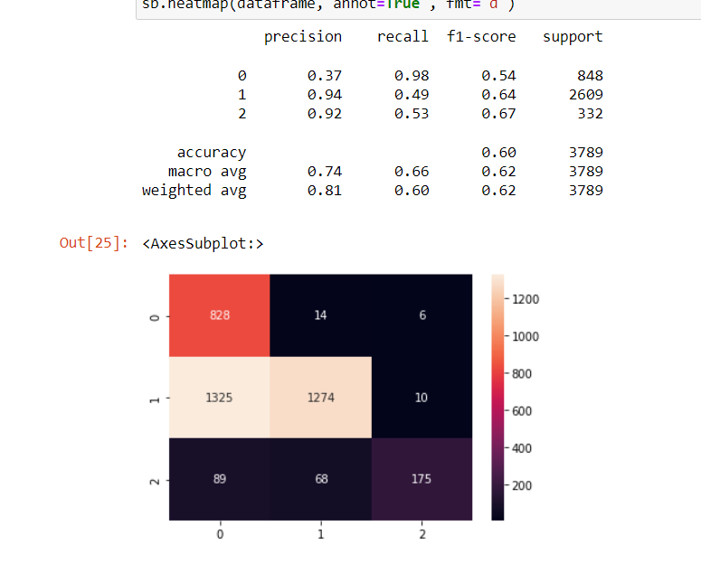

1. Convolutional Neural Network (91%)

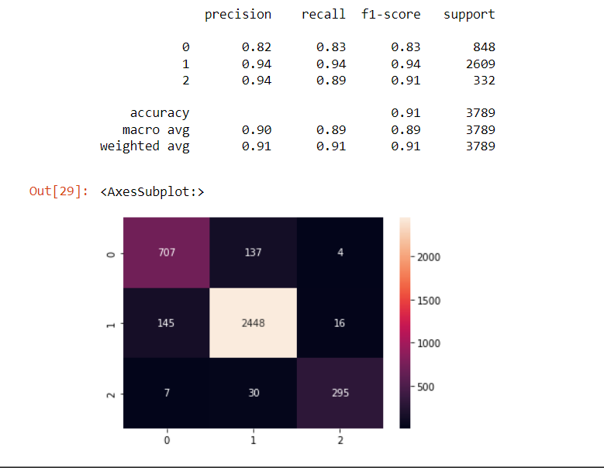

1. Convolution Neural Network-LBP (94%)

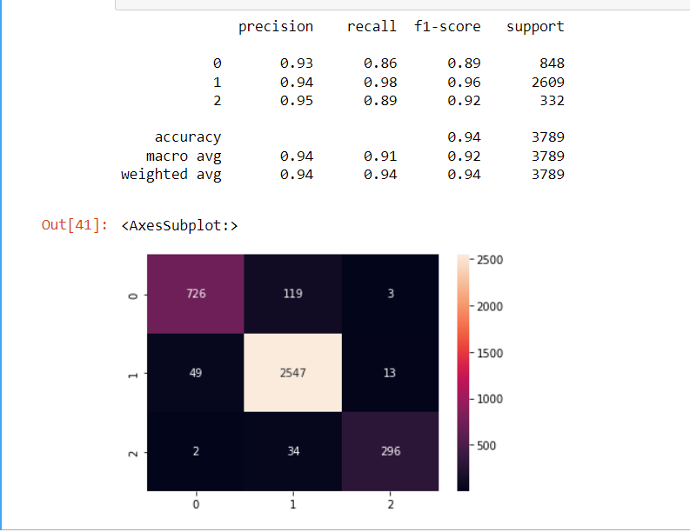

1. 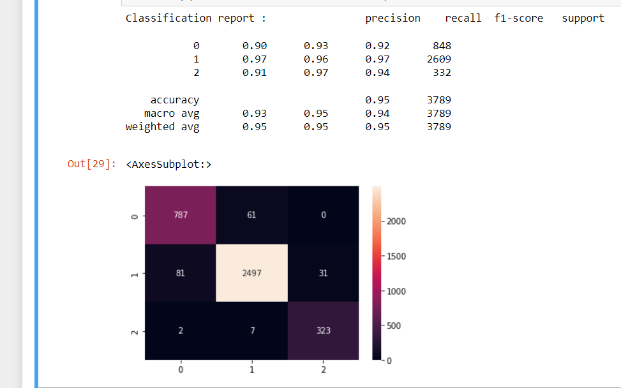Convolutional Neural Network-HOG-LBP (95%)

**Comparison table**

|  |  |  |
| --- | --- | --- |
| **S/N** | **Deep Learning model** | **Accuracy** |
| **1** | ANN | **60%** |
| **2** | CNN | **91%** |
| **3** | CNN-LBP | **94%** |
| **4** | CNN-LBP-HOG | **95%** |

**Techniques comparison using bar chart**

